

Product Price Sheet
The following products are available for order. All prices are listed in USD and exclude shipping costs. For additional details or to place an order, please contact WoundVision Sales.

Product Name | Product Code | Price (USD) | Notes
SCA200 Protective Sleeve  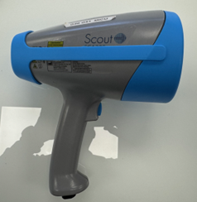 | 3484M0201 | $49.00 + shipping | Blue, slip-resistant rubber sleeve

